(New York - Los Angeles) A truck must travel from New York to Los Angeles. As shown in [Figure below](javascript://), several routes are available. The number associated with each arc is the number of gallons of fuel required by the truck to traverse the arc. Determine the route from New York to Los Angeles that uses the minimum amount of gas.

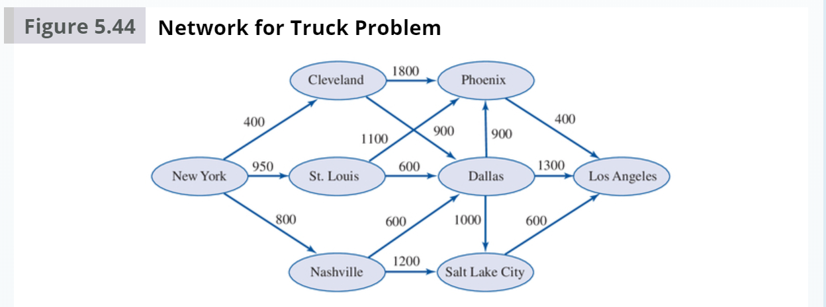

**Discussion: -**

Our objective in the problem is to optimize the route (finding the shortest path) in such a way that our truck reaches the destination with minimum amount of gas. We have gallons required to travel from one city to another city. If we can decide in which path our truck travels, we can calculate the Total amount of gas. So, our decision variable should be binary (0 or 1), where 1 denotes truck travels in that route(arc). We must assume the cities as nodes. In our problem, New York is the origin node and Los Angeles is destination node. Shortest route problems can be modeled as a special case of more general logistics models, using a “supply” of 1 at the origin node and a “demand” of 1 at the destination node.

Our optimal solution is to find out a path, which means all the city nodes (except Origin and destination) “supply” should match with the “demand”. Below figure illustrates how we are going to define this constraint in our model.

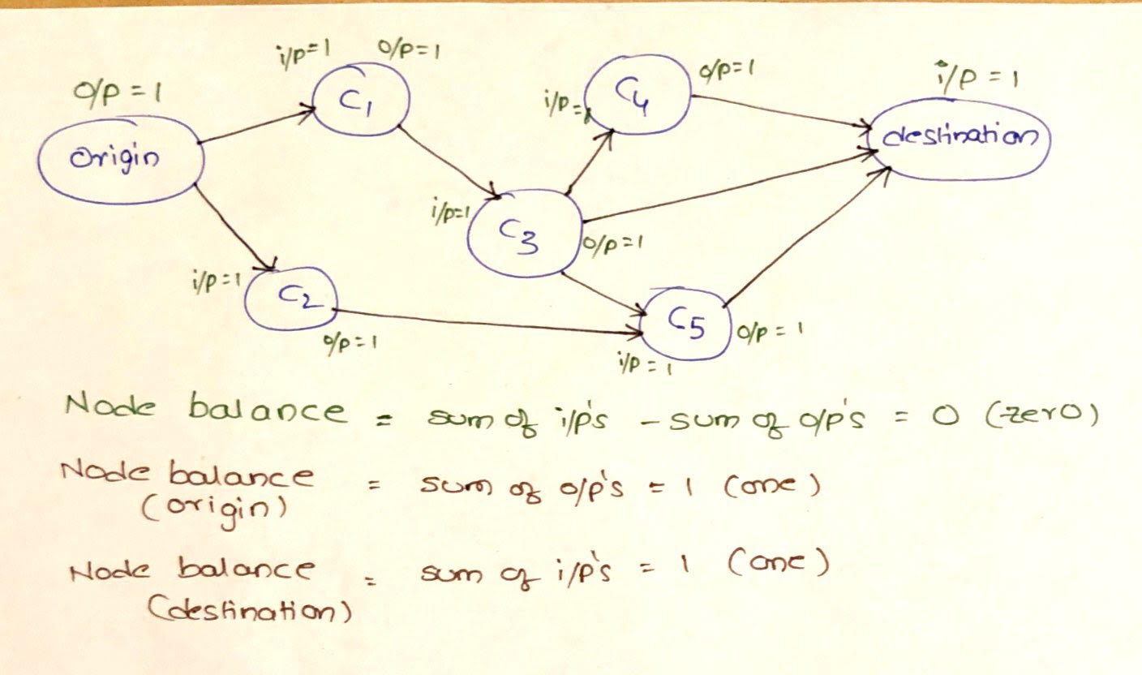

**Mathematical Model: -**

*Parameters (Inputs):*



$$i ϵ 1,2,3..8 \left( i: Index for city nodes\right)$$

$$j ϵ 1,2,3..8 \left( j: Index for city nodes\right)$$

$$A_{ij} : Fuel in gallons to travel from city i to city j$$

$$R_{i }:Required net outflow for node i;R_{1 }=1, R_{8 }=-1,R_{2 } to R_{7 }=0$$

*Decision Variables:*

$$x_{ij} :Decision whether to travel in route i to j$$

*Objective:*

$$Minimize total fuel=\sum_{j=1}^{8}{\sum_{i=1}^{8}{\left(x_{ij}*A_{ij}\right)}}$$

*Constraints:*

$$x_{ij }ϵ \{0,1\} \left(1\right) Binary constraint$$

$$\sum_{j=1}^{8}{x_{ij}}- \sum_{j=1}^{8}{x_{ji}}≥ R_{i } ; for iϵ\left\{1,2,3,…8\right\} \left(2\right) Net outflow constraint$$

As highlighted in our discussion, NetFlow constraint will make sure that the input of a node is equal to the out of the node for all the cities except origin and destination.

*Excel Implementation:* Please find the attached spreadsheet for solution.

Optimized Path: 1 --> 3 --> 5 --> 8

Optimized Path: New York --> St Louis --> Phoenix --> Los Angeles

 